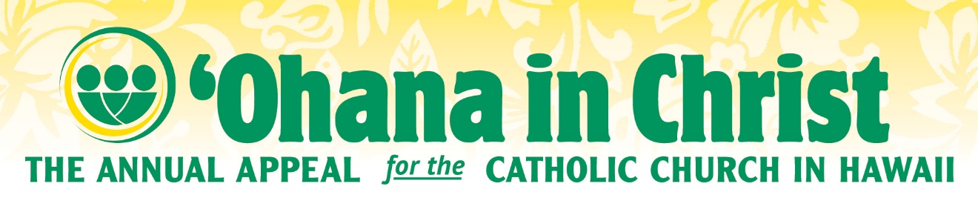

‘Ohana in Christ 2024/2025

November 16&17

- Last weekend, we held our annual commitment weekend for the ‘Ohana in Christ appeal. To those who have already generously given to this appeal, I say thank you!

- If you haven’t made a commitment yet, I hope you have taken time to consider how you can support this year’s effort which delivers ministries to those seeking to expand their faith and education as well as provides essential ministries throughout our diocese.

- I’d invite you to use your phone to scan the QR code located in the pews or on the pledge cards or go to Appeal.CatholicHawaii.org where you’ll be able to make an ongoing recurring gift or a one-time gift. That website again: Appeal.CatholicHawaii.org
- Thank you for your support!

